First Baptist Church
Saturday, June 11th, 2022
9:00 AM – 2:00 PM

Inside Yard Sale

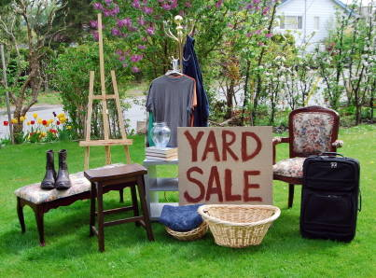

May need to bring your own table.
Set up is at 7:00 AM

Biscuits and Gravy – 8:30 AM
Lunch at 11:30AM
Youth will be serving meals to raise funds for
their mission trip in June.

Please bring those items to sell that could be
treasured by someone else.
Church table will be donation on some
items and some will be priced.

For questions call or text:
Judy Thompson – 317-370-7616
Email-judythompson25@yahoo.com
Or FBC – 342-3616

First Baptist Church
1109 E. Columbus Street
Martinsville, IN

