Annual Craft Fair

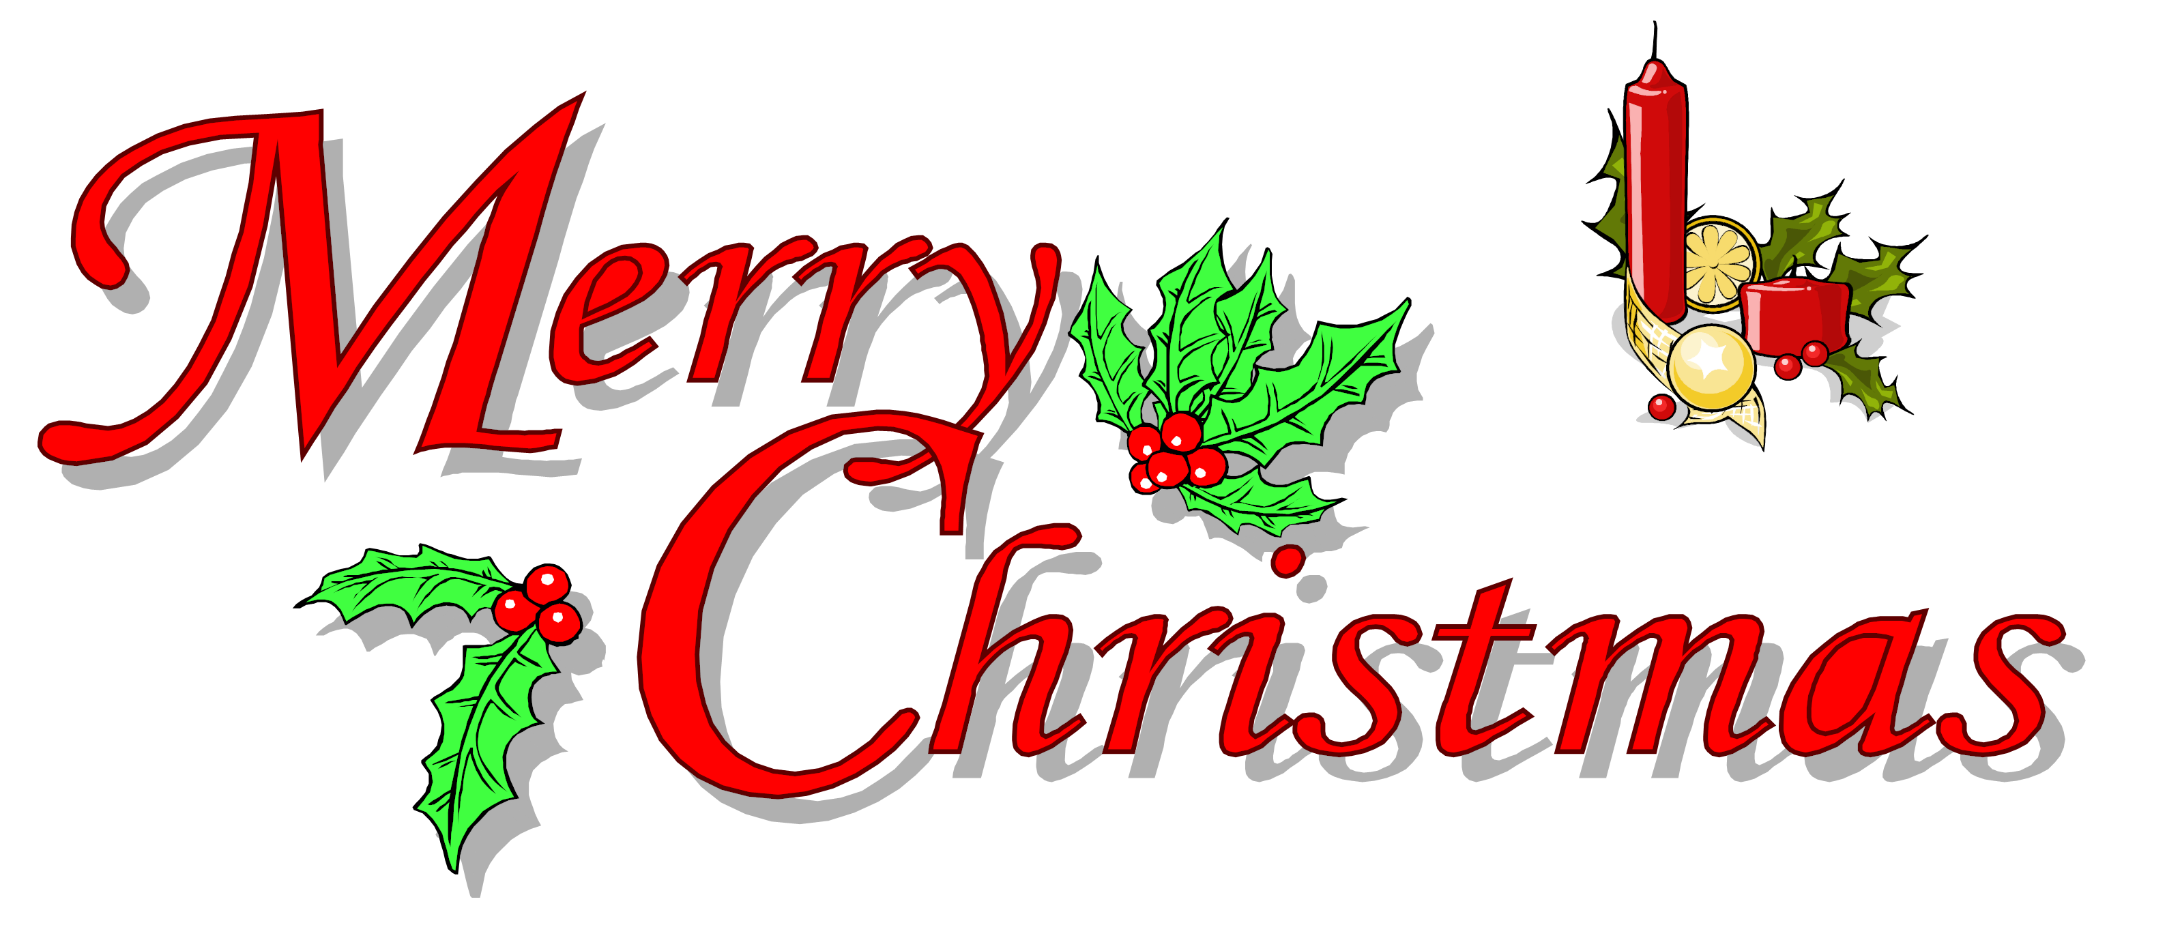

Saturday, November 6, 2021
8:00 AM – 2:00 PM

There will be Jewelry, Pink Zebra (candle stuff), Christmas decorations, nail care, Lemongrass (natural oils), Avon, Paparazzi (New Clothing Styles), and Baked Goods and many other crafts.

Booth Space- $25.00
(10’ x 10’)
Set-up Friday, 6:00 PM to 8:00 PM
Or Sat, 6:30AM – time of Craft Fair

Martinsville First Baptist Church
1109 E. Columbus Street
For more info.
Call Judy Thompson - 317-370-7616
Or FBC 765-342-3616
