
ABC Organization


Focus on the Family-Dr. James Dobson
www.family.org


http://www.judsonpress.com/catalog/
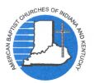
The Baptist Observer
http://www.abc-indiana.org/

http://bible.gospelcom.net/bible?language=English&version=NIV
Parental Review
Parenting information-guidelines for movies, etc...
www.screenit.com

