 

The Vision

**FIRST BAPTIST CHURCH, MARTINSVILLE**

1109 E. Columbus St.; Martinsville, IN 46151

Church Office, 765-342-3616

e-mail - [fbcmart@sbcglobal.net](mailto:fbcmart@sbcglobal.net);

Web - http://www.firstbaptistmartinsville.org

**May 15, 2022**

“This is the day the Lord has made, we will rejoice and be glad in it!” Good morning everyone! The Lord is good! His mercies are everlasting! God is here and desires to speak to hearts. We pray this will be a dynamic hour as the Lord is in our midst!

Let’s all approach this hour with expectancy! We all are not here by accident! Let us make a joyful sound together as we praise our Lord!

We welcome our guests among us! What a joy you give us to see you here. Relax and enjoy this hour of praise. Hopefully I can connect with you personally before you leave today. You are among friends!

Love,

Pastor John & Debbie



***Your fellowship today is important to us. Please fill out the attendance pads at the end of each pew.***



In His Service

**May 22, 2022**

SOUND SYSTEM­­ 10:30 AM-Chuck Richardson

DEACON–Ken McVey

Small Talk-Jacquie Woodard

*(The previous week’s attendance and financial status)*

ATTENDANCE

SS-38 Worship- 73

FINANCIAL NOTES

Monthly Need $11,070.16

**Worship Service Sunday School**

**May 1 $1,705.00 $43.00**

**May 8 $3,231.00 $46.00**

**-**

Operating Fund

$5,025.00

**SPECIAL OFFERINGS**

B’day and Anniversary offering-$7.00,

Trash Bags-$20.00, Love Gift-Church-$9.30,

Love Gift-ABW-$15.00, Bereavement Fund-$22.00, Kroger-$96.16

Total Receipts (May.) $5,765.31

Weekly Need $2,700.18

**DEAR NAME**

“*Jesus*.” Say My Name often. It was in My Name Peter bade the lame man walk. “In the Name of *Jesus* Christ of Nazareth arise and walk.”

“*Jesus*.” The very sounding of My Name, in Love and tenderness, drives away all evil. It is the word before which all the hosts of evil flee.

“*Jesus*.” The Name is the call for a life-line to rescue from temptation.

“*Jesus*.” The Name banishes loneliness—dispels gloom.

“*Jesus*.” Summons help to conquer your faults.

I will set you on high because you have known My Name.

Yes! My Name—“*Jesus*.” Use it more. Use it tenderly. Use it prayerfully. Use it powerfully.

“From *God Calling*, published by Barbour Publishing, Inc. Used by permission”



***Reserve you booth now and start planning***

***on what you can donate***

**First Baptist Church will be having a Spring Yard Sale on Saturday, *June 11th* from 9:00 AM to 2:00 PM in the FLC. Booth space is available for $25.00. Set up time will be 6:00 to 8:00 PM Friday evening or 6:00 AM on Saturday morning. To reserve a booth, or if you do not want a booth, but have items you would like to donate to the church for the sale, call Judy Thompson at 317-370-7616 or the church 342-3616. A booth is a 10 X 10 space.**

**DID YOU KNOW**

The Chapel Choir from Broadway Baptist Church, Ft. Worth, TX (a 35 member teen choir/handbell choir) will be with us the weekend of July 1-3 as part of their summer tour? They will be giving us an evening concert on Friday July 1st, will be doing mission projects for us on Saturday the 2nd, and will be leading out in our Sunday Worship service on July 3rd!  Pastor John’s daughter Emily is the director of this choir. Emily, her husband Clayton and Pastor John’s granddaughter Abbey will be with them as they minister with us, along with other adult sponsors.

They will be sleeping in the Family Life Center Friday and Saturday night as they will be bringing sleeping bags and air mattresses. Our own YMCA and Bell Academy have graciously offered to provide shower facilities during their stay. We will provide a lunch for them on Saturday. Mark your calendars! It will be a great weekend for the Glory of God!

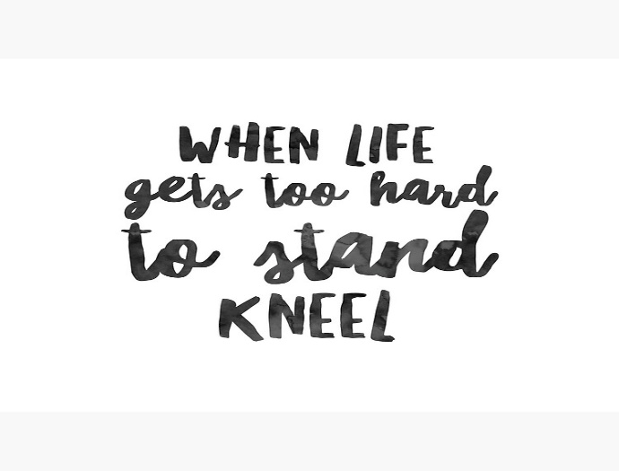

**ATTENTION LADIES!**

On August 13, 2022 the Hearts In Service annual retreat will be held right here at First Baptist Church. Please come join us for fun, fellowship and praising our Lord. Any questions call:

Jacquie Powers at:

317-403-6000

**BANQUET WEEKDAY RELIGIOUS**

**ED PROGRAM**

**ALL SCHOOLS**  
  
May 26 – 2022 – 6:30

First United Methodist Church

Contact Sharon Reid

765-516-0334



**PRAYER REQUESTS:**

**Church Family:**

Judy Thompson, Jim Abshire, Bertha Marie Heiny, Carol Williams, Kathy Morris, Evelyn Denney, Mary Jennison, Brian Etchison, Susan Polk,

Dee Dee Kaufman, Donna Abshire,

Betty Williamson, Mike Adams, Tom Holman, Larry & Peggy Martin, Bob & Catherine Etter & Bob & Dianna Jennings.

**Community: Pray for America,**

our community, the leaders, our school boards.

For children and teachers in school this year and those in need in our community.

**Military Personnel:** Skyler Rynard,

Dan Koong, Michael Pitz, Clint Plake,

Daniel Hill and all military personnel serving at home and abroad**.**

**Country** People affected by the COVID-19, Situations in the country and abroad, the President, cabinet, political leaders, military personnel,

our nation, police, the US economy, firemen and medical personnel.

**World:** Peace, Middle Eastern conflict, global financial situation, and those serving on the mission field.

[](https://www.churchart.com/subscriber/viewimages?topic_id=156&image_type=cl%2Cph%2Cpp%2Cbc%2Cca%2Cmv%2Cwt%2Cnt%2Cpt%2Cft%2Cea)