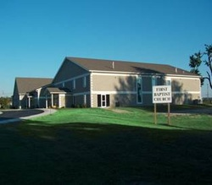  We invite you to grow  together with us in your  personal relationship  with God through  Jesus Christ and in your  relationship with other  people at home, at work  and in our community. | First Baptist Church Martinsville  Early Worship 8:30 AM  Sunday School 9:30 AM  Worship Service 10:30 AM  Tuesday Bible Study 10:00 AM  Wednesday Bible Study 6:30 PM  Youth  Sunday AWANA Club 5:15-7:00 PM  1109 E. Columbus Street  Martinsville, IN 46151  Phone: 765-342-3616  Pastor: Larry Osmon

